Video Guidelines
A recent video of the individual who is being referred enables us to make decisions about the service to be offered and to plan and prepare more effectively. The information we receive from you is treated with confidence and seen only by members of the Ace Centre team. The purpose of the video is to inform on the most effective service available from us to identify how assistive technology may enhance the person’s opportunities to communicate and / or access learning.
In order to establish the individual’s present level of function, it would be useful to receive a video showing the following situations:
- Communication – how the individual is communicating with others in learning and / or social contexts. This should include examples of receptive skills, e.g. demonstrating understanding of a question, or responding to a preferred activity. There should also be examples of the individual’s expressive skills indicating their current strategies for communicating with others, e.g. vocalisation, use of AAC (Alternative and Augmentative Communication), gesture, eye pointing.
- Access/positioning–how the individual interacts with their environment. Please show examples of their physical abilities including mobility, hand function, head control, or any other voluntarily controlled movement. The video should show the individual in any positional equipment they use when working, e.g. seating systems.
- Present use of assistive technology – please show how any equipment available at present is being used, such as a computer with appropriate software and access devices (e.g. alternative mouse, keyboard or switch use) and / or communication aids. It is always helpful for us to see the individual using familiar technology in order to understand any difficulties they are currently experiencing.
- Environment – it is useful to have an indication of the contexts in which any assistive technology may be useful. This may include their learning environment, leisure activities and/or home.
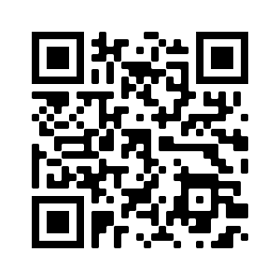
The contexts for recording as suggested should consist of a few minutes at a time only in order to provide us with an indication of the individual’s needs in relation to assistive technology. Please limit the recoding time to a maximum of 20 minutes.
Please send videos in a digital format such as on a CD/DVD, memory card, or email of short mobile phone videos. You can also upload your videos directly to us by uploading them to this folder: https://acecent.re/video-upload (scan the QR code you’re your camera to take you to the site). Note for privacy the files are removed out of public view as soon as they are uploaded. Please let us know when you have done this. Alternatively, you may wish to upload your video to a password-protected internet video site such as Vimeo (www.vimeo.com). If so, please let us have the access details.

